**Teacher Performance Expectation (TPE) Developmental Continuum**

**Purpose and Design**: The purpose of this continuum is to guide the development of beginning teaching aligned with California’s Teacher Performance Expectations. It was designed to span the continuum of preservice teacher development, from beginning teacher candidacy to teaching certification. In general, the descriptor for Levels 1 – 3 explicates performance expectations for the Beginning Placement (Fall Quarter). Similarly, the descriptor for Levels 4 – 6 represents expectations for Intermediate Placement (Winter Quarter) and Levels 7 – 9 for Advanced Placement (Spring Quarter).

**STUDENT TEACHER:       SUPERVISOR:       COOPERATING TEACHER:**

|  |  |  |  |  |
| --- | --- | --- | --- | --- |
| Content Pedagogy | Developmental Continuum | **Beginning Levels 1, 2, 3**  *Fall performance level expectation is 3* | **Developing 4, 5, 6**  *Winter performance expectation is 6* | **Advanced 7, 8, 9**  *Spring performance expectation is 8 or 9* |
| Demonstrates **knowledge of subject matter**, including the adopted California State Standards and curriculum frameworks. 3.1  Uses **knowledge about student**s and learning goals to organize the curriculum to facilitate **understanding of subject matter**, and make **accommodations and/or modifications** as needed to promote student access to the curriculum. 3.2  **Plans, designs, implements, and monitors instruction** consistent with current **subject-specific pedagogy** in the content area(s) of instruction, and designs and implements disciplinary and **cross-disciplinary** learning sequences. 3.3  **Adapts** **subject matter** curriculum, organization, and planning to support the acquisition and use of **academic language** within learning activities to promote subject matter knowledge of all students. 3.5 | **Beginning practices:**  Performance Levels 1 (some of these activities), 2 (many), 3 (most or all)   * Creates lesson plan objectives that incorporate **subject-specific pedagogy**. * Plans learning **objectives that build on students’ prior knowledge**. * Planned student grouping supports **engagement** and learning. * Planned content-specific instructional strategies support students to **reach** the learning **expectations**.   **Developing practice:**  Performance Levels 4 (some of these activities), 5 (many), 6 (most or all)   * Plans include **modeling and scaffoldin**g that will support student learning. * Includes **activities that are engaging, challenging, and/or accessible** for students. * A**ligns** academic content standards, instruction and assessment (formative, formal, self, peer). * E**nsures clear connections** **and relevance** to students. * Implements learning activities in single lessons or sequence of lessons that draw on **students’** **assets and strengths.** * Provides **explicit teaching of essential vocabulary, idioms, key words with multiple meanings, and academic language** in ways that engage students in accessing subject matter text or learning activities.   **Advanced teaching:**  Performance Levels 7 (some of these activities), 8 (many), 9 (most or all)   * Uses knowledge of student development and proficiencies to **adapt instruction** and meet individual student learning needs. * Integrates **assets** of s**tudents, families, and communities** into teaching in ways that empower students and encourage ownership of their own learning. | ***FALL RATING*:** | | |
| ***WINTER RATING*:** | | |
| ***SPRING RATING*:** | | |

|  |  |  |  |  |
| --- | --- | --- | --- | --- |
| Achievement: Intellect and Skills | Developmental Continuum | **Beginning Levels 1, 2, 3**  *Fall performance level expectation is 3* | **Developing 4, 5, 6**  *Winter performance expectation is 6* | **Advanced 7, 8, 9**  *Spring performance expectation is 8 or 9* |
| **Monitors** student learning and **adjusts** instruction while teaching so that students continue to be **actively engaged** in learning. 1.8  Maintains **high expectations** for learning with **appropriate support** for the full range of students in the classroom. 2.5  Demonstrates knowledge of the purposes, characteristics, and appropriate uses of **different types of** **assessments**. 5.1  Collects and analyzes **assessment data** from multiple measures and sources (including information from IEP, IFSP, ITP and 504 plans) **to plan and modify instruction** and document students' learning over time. 5.2, 5.8 | **Beginning practices:**  Performance Levels 1 (some of these activities), 2 (many), 3 (most or all)   * Holds **high expectations** for students. * **Monitors** student learning during instruction and provides **assistance** to students individually or in small groups.   **Developing practice:**  Performance Levels 4 (some of these activities), 5 (many), 6 (most or all)   * Creates a **rigorous learning environment** focused on **accuracy, analysis, problem solving**, and appropriate levels of challenge. * Incorporates **higher order questions** and opportunities for **student inquiry** * Develops and adapts the **range of appropriate assessments** (formative, summative, self, peer) to promote deep learning of content, academic language development, and higher order thinking. * **Adjusts** instruction based on regular checks for understanding and observation of student engagement. * Uses analysis of a variety of data to **inform planning and differentiation** of instruction.   **Advanced teaching:**  Performance Levels 7 (some of these activities), 8 (many), 9 (most or all)   * Provides differentiated supports for **critical reading, writing thinking**, higher order thinking, and problem solving across subject matter. * Provides **assistance and feedback** individually or in small groups during instruction, and provides opportunities for students to **incorporate the feedback** to improve their work and understandings. * Uses a variety of assessments to **allow students with a range of learning needs to demonstrate what they know**. * Communicates regularly with resource personnel, para-educators, and families to ensure that student services are provided and progress is made in accessing appropriate content. | ***FALL RATING*:** | | |
| ***WINTER RATING*:** | | |
| ***SPRING RATING*:** | | |

|  |  |  |  |  |
| --- | --- | --- | --- | --- |
| Experiences | Developmental Continuum | **Beginning Levels 1, 2, 3**  *Fall performance level expectation is 3* | **Developing 4, 5, 6**  *Winter performance expectation is 6* | **Advanced 7, 8, 9**  *Spring performance expectation is 8 or 9* |
| Establishes and maintains **clear expectations** for positive classroom **behavior** and for student-to- student and student-to-teacher interactions by communicating classroom **routines, procedures, and norms** to students. 2.6  Makes effective use of **instructional time** to maximize learning opportunities for all students. 4.4a  Plans and implements **Universal Design for Learning[1]** strategies and appropriate modifications in order to provide access to the curriculum for all students. 4.4b  Plans for and effectively orchestrates opportunities for **students to support each other** in learning. 4.4d  Plans instruction that promotes a range of **communication strategies and activity modes** between teacher and student and among students. 4.7 | **Beginning practices:**  Performance Levels 1 (some of these activities), 2 (many), 3 (most or all)   * Creates, models, explains and reviews **expectations** for respectful, purposeful and productive learning with students. * Maintains a positive, respectful, inclusive **learning climate** that builds on student strengths. * Plans and uses a range of **structured, supportive interactions** between students that support their own and their peers’ learning. * Asks **questions** in discussions, tasks or assessments that require students to recall, interpret, and **think critically** and that elicit **oral or written responses** by students.   **Developing practice:**  Performance Levels 4 (some of these activities), 5 (many), 6 (most or all)   * Uses **multiple strategies, including culturally responsive instruction**[2], to develop and maintain **high standards for** individual and group **behavior**. * **Promotes positive behaviors** and prevents or refocuses behaviors not supportive of a productive and purposeful learning environment. * **Paces instruction** with students to provide adequate time for instruction, **checking for understanding, completion of learning activities, closure,** with **options for extension and review**. * Engages students in a range of **communication strategies** (collaborative, interpretive, productive) and **activity modes** between teacher and student and among students that are **culturally responsive** and engage students in the development and monitoring of norms. * Structures student talk so that there is **equity of voice**, and that thinking and problem solving are shared?   **Advanced teaching:**  Performance Levels 7 (some of these activities), 8 (many), 9 (most or all)   * Guides and supports **students to self-assess, monitor, and set goals** for individual and group behavior and participation. * **Engages students in monitoring and reflecting on communication strategies and activity modes** in ways that are **culturally responsive**. * Identifies strengths and competencies of all students to provide appropriate challenge and accommodations, drawing from ***Universal Design for Learning*** strategies. | ***FALL RATING*:** | | |
| ***WINTER RATING*:** | | |
| ***SPRING RATING*:** | | |

|  |  |  |  |  |
| --- | --- | --- | --- | --- |
| Critical Lens/ Advocacy | Developmental Continuum | **Beginning Levels 1, 2, 3**  *Fall performance level expectation is 3* | **Developing 4, 5, 6**  *Winter performance expectation is 6* | **Advanced 7, 8, 9**  *Spring performance expectation is 8 or 9* |
| Promotes **critical and creative thinking** and analysis through activities that provide opportunities for **inquiry, problem solving**, responding to and framing meaningful questions, and reflection. 1.5  **Reflect** on their own teaching practice and level of subject matter and pedagogical knowledge to plan and implement instruction that can improve student learning. 6.1  Demonstrate **professional responsibility** for all aspects of student learning and classroom management, including responsibility for the learning outcomes of all students. Beginning teachers **conduct themselves with integrity** and model ethical conduct for themselves and others. 6.5 | **Beginning practices:**  Performance Levels 1 (some of these activities), 2 (many), 3 (most or all)   * Begins to engage in **reflection** on teaching practice individually and with colleagues that is focused on methods to **support the full range of learners** * Listens, acknowledges, supports and responds to student voices, opinions, ideas and questions * Provides descriptive feedback to students on the quality of their work; provides opportunities for students to apply the feedback to deepen their understandings.   **Developing practice:**  Performance Levels 4 (some of these activities), 5 (many), 6 (most or all)   * Reflects on teaching practice individually and with colleagues, staff and families that is focused on ways to **support the full range of learners**. * Conducts self professionally and with integrity. * **Maintains professional responsibilities** in timely ways and **seeks support** as needed.   **Advanced teaching:**  Performance Levels 7 (some of these activities), 8 (many), 9 (most or all)   * Supports families in positive engagement with the school. * Initiates and monitors referral processes and follow-up meetings to ensure that students receive support and/or extended learning integrated into the core curriculum. * Maintains an **inclusive, culturally responsive and sustaining environment** for students, families and colleagues. | ***FALL RATING:*** | | |
| ***WINTER RATING:*** | | |
| ***SPRING RATING:*** | | |

|  |  |  |  |  |
| --- | --- | --- | --- | --- |
| Connections and Identity | Developmental Continuum | **Beginning Levels 1, 2, 3**  *Fall performance level expectation is 3* | **Developing 4, 5, 6**  *Winter performance expectation is 6* | **Advanced 7, 8, 9**  *Spring performance expectation is 8 or 9* |
| Supports students’ first and/or second **language acquisition** by using research-based instructional approaches, including focused English Language Development, Specially Designed Academic Instruction in English (SDAIE ), scaffolding across content areas, and structured English Immersion[3]. 1.6  Uses **developmentally, linguistically, and culturally appropriate** learning activities, instructional materials and resources. 4.4c | **Beginning practices:**  Performance Levels 1 (some of these activities), 2 (many), 3 (most or all)   * Makes **connections** in teaching between subject matter and real-life contexts, incorporating **culturally**-**relevant resources**, materials, tools, and/or educational technology. * Plans instruction using **assessment information on student academic readiness, language, cultural background, and individual development**. * Support EL understanding using visuals, models or graphic organizers.   **Developing practice:**  Performance Levels 4 (some of these activities), 5 (many), 6 (most or all)   * Uses knowledge of students’ language and cultural background, English language proficiencies and English learner strengths to develop and adapt instruction; provides scaffolded-supports for language and content for the range of English learners. * **Examines potential sources of bias and stereotyping** when planning lessons. * Plans and uses **culturally-responsive and sustaining pedagogy**.   **Advanced teaching:**  Performance Levels 7 (some of these activities), 8 (many), 9 (most or all)   * Plans and implements **differentiated instruction** based on **knowledge of students’** academic readiness, academic language, diverse cultural backgrounds, and individual cognitive, social, emotional, and physical development. * Provides student choice in the use of **relevant resources**, materials, tools, and/or educational technology to enhance student understanding, access and engagement. * Applies knowledge of English language development and **English learner’s strengths** **and** **assessed needs to differentiate** content, process, products and/or assessment to support English learners to use one or more components of English language development (vocabulary, functions, forms, fluency). | ***FALL RATING*:** | | |
| ***WINTER RATING*:** | | |
| ***SPRING RATING*:** | | |

|  |  |  |  |  |
| --- | --- | --- | --- | --- |
| Community: Inclusivity and Joy | Developmental Continuum | **Beginning Levels 1, 2, 3**  *Fall performance level expectation is 3* | **Developing 4, 5, 6**  *Winter performance expectation is 6* | **Advanced 7, 8, 9**  *Spring performance expectation is 8 or 9* |
| Provide students with opportunities to access the curriculum by incorporating the visual and performing arts, as appropriate to the content and context of learning. 1.3  Provide students with opportunities to access the curriculum by incorporating the visual and performing arts, as appropriate to the content and context of learning. 1.7  Establishes, maintains, and monitors **inclusive learning environments** that are physically, mentally, intellectually, and emotionally healthy and safe to enable all students to learn. 2.3 | **Beginning practices:**  Performance Levels 1 (some of these activities), 2 (many), 3 (most or all)   * Maintains an assurance of **safety**, **belonging**, **value** and **fairness** when teaching. * Recognizes and addresses safety issues regarding materials, student interactions, and the organization of the learning environment. * Models and explicitly teaches **respectful behaviors**. * Involves the arts as part of the curriculum.   **Developing practice:**  Performance Levels 4 (some of these activities), 5 (many), 6 (most or all)   * **Models and communicates an assurance of safety, belonging, value and fairness** to all students. * Models and provides instruction on skills that develop **resiliency** and support **intellectual and emotional safety**. * Provides **opportunities** for all students to contribute to the class, take risks, offer opinions, share alternative perspectives, and take on meaningful responsibilities. * Gives purposeful attention to the arts as a means for human expression.   **Advanced teaching:**  Performance Levels 7 (some of these activities), 8 (many), 9 (most or all)   * Engages students to offer **respectful opinions about divergent viewpoints** and to **reflect** on their own language and behavior that contribute to intellectual and emotional well-being of one another. * Provides opportunities for students to engage in a variety of self-expression in connection with their learning. | ***FALL RATING*:** | | |
| ***WINTER RATING*:** | | |
| ***SPRING RATING*:** | | |

**Individual Development Plan**

|  |
| --- |
| ***Quarterly Summary* (Fall and Winter) and End-of-Year *Individual Development Plan* (Spring)**  *(complete collaboratively by Teacher Candidate and Teacher Supervisor)* |
| **FALL Quarter Summary** |
| **Evidence of TPE Strengths**: |
| **TPE Target Growth Areas**: |
| **Next Steps**: **What will we see in your teaching that demonstrates growth toward achieving your goals?** |
| **WINTER Quarter Summary** |
| **Evidence of TPE Strengths**: |
| **TPE Target Growth Areas**: |
| **Next Steps**: **What will we see in your teaching that demonstrates growth toward achieving your goals?** |
| **SPRING: Individual Development Plan (for Induction)** |
| **Evidence of TPE Strengths**: |
| **TPE Target Growth Areas**: |
| **Next Steps**: **What will we see in your teaching that demonstrates growth toward achieving your goals?** |

**UCSC MA/Credential Program Wheel of Social Justice**

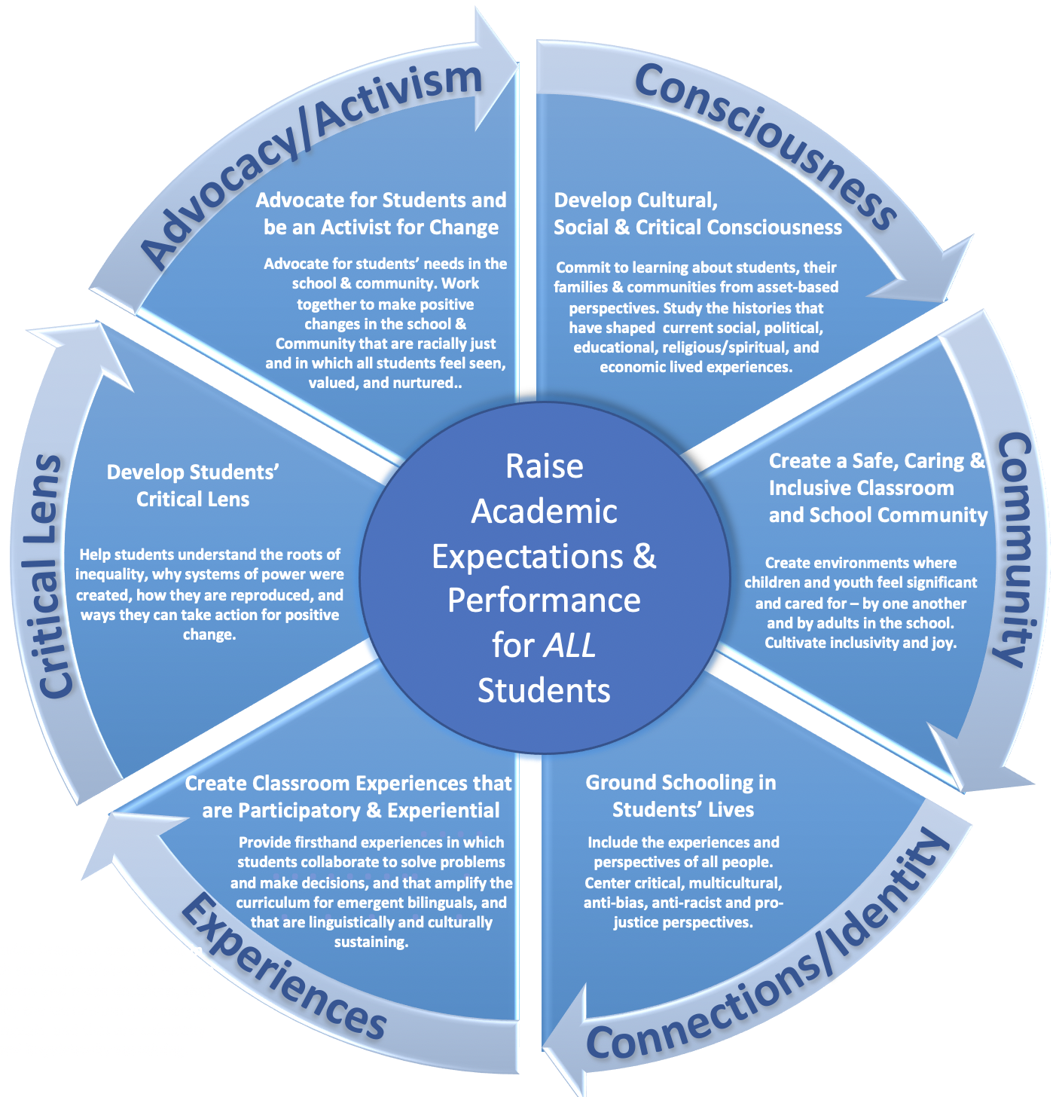

1. Universal Design for Learning Principles include: providing multiple means of representation of information; clarification and support for vocabulary, text, symbols, and expressions; comprehension strategy instruction; providing multiple means for expression and communication to demonstrate understandings; structuring student planning, goal setting, progress monitoring, managing information and resources; providing multiple means for engagement through choice, relevance and minimization of distractions, collaboration, community, varied demands and resources to maximize challenge, mastery-oriented feedback, self-assessment, and reflection.
2. **Cultural practices** shape thinking processes, which serve as tools for learning within and outside of school. Culturally responsive education recognizes, respects, and uses students' identities and backgrounds as meaningful sources for creating optimal learning environments. **Culturally Responsive Practices**: **Communication of High Expectations** − Consistent messages from the teacher and school that students will succeed, based upon genuine respect for students and belief in student capabilities. **Active Teaching Methods** – Active engagement of students play in crafting curriculum and learning activities. **Teacher as Facilitator** − Teacher's role is one of guide, mediator, and knowledgeable consultant, as well as instructor. **Positive Perspectives on Parents and Families of Culturally and Linguistically Diverse Students** − Ongoing participation in dialogue with students, parents, and community members on issues important to them, along with the inclusion of these individuals and issues in classroom curriculum and activities. **Cultural Sensitivity** − Teachers acquire knowledge of the cultures represented in their classrooms and translate this knowledge into instructional practice. **Reshaping the Curriculum** − A reshaped curriculum is culturally responsive to the background of students. **Culturally Mediated Instruction** − Instruction is characterized by the use of culturally mediated cognition, culturally appropriate social situations for learning, and culturally valued knowledge in curriculum content. **Student−Controlled Classroom Discourse** − Students are given the opportunity to control some portion of the lesson, providing teachers with insight into the ways that speech and negotiation are used in the home and community. **Small Group Instruction and Academically−Related Discourse** Instruction is organized around low−pressure, student−controlled learning groups that can assist in the development of academic language. (*Obtained from knowledgeloom.org, Brown University*.)
3. Structured English Immersion (SEI): Dedicated instructional time for teaching the English language in language-ability groupings; language content and English grammar instruction have primacy over academic content during SEI instruction.